***Homework 2***

Azamat Salamatov

MATH 1312 - STATISTICS

Professor Marvin E. Johnson

February 23, 2023

# Homework 2

## Section 75:

***Q:*** 75. Table 2.61 contains the 2010 obesity rates in U.S. states and Washington, DC.

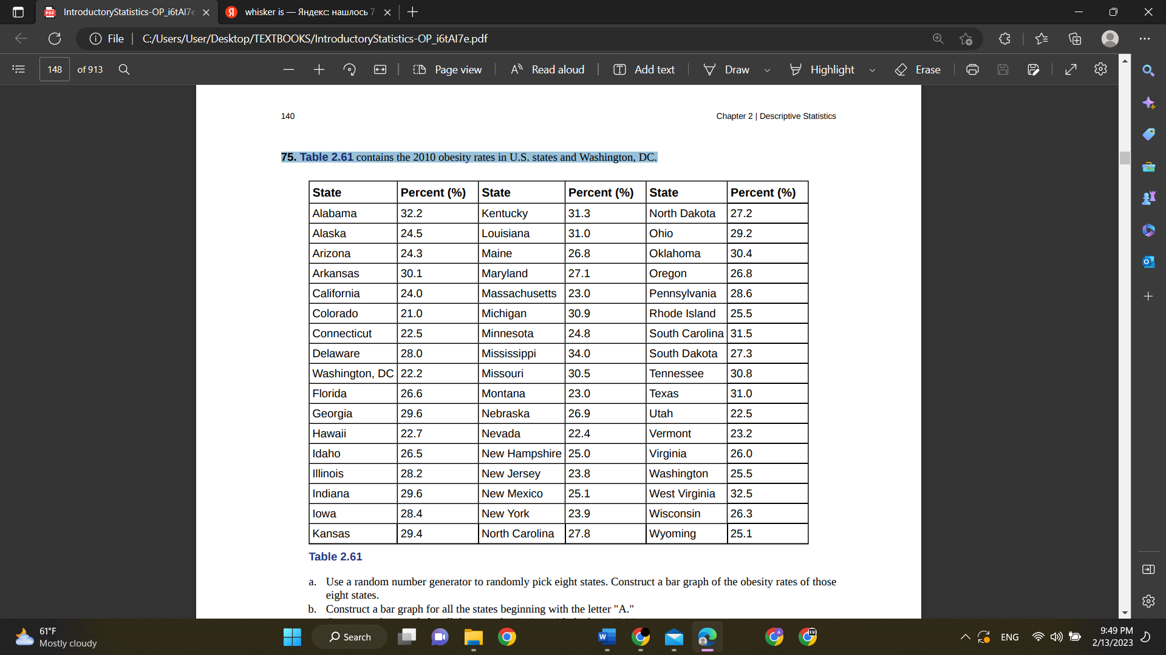

a. Use a random number generator to randomly pick eight states. Construct a bar graph of the obesity rates of those eight states.

b. Construct a bar graph for all the states beginning with the letter "A."

c. Construct a bar graph for all the states beginning with the letter "M."

Answer:

A)

B)

C)

## Section 79:

Use the following information to answer the next two exercises: Suppose one hundred eleven people who shopped in a special t-shirt store were asked the number of t-shirts they own costing more than $19 each.

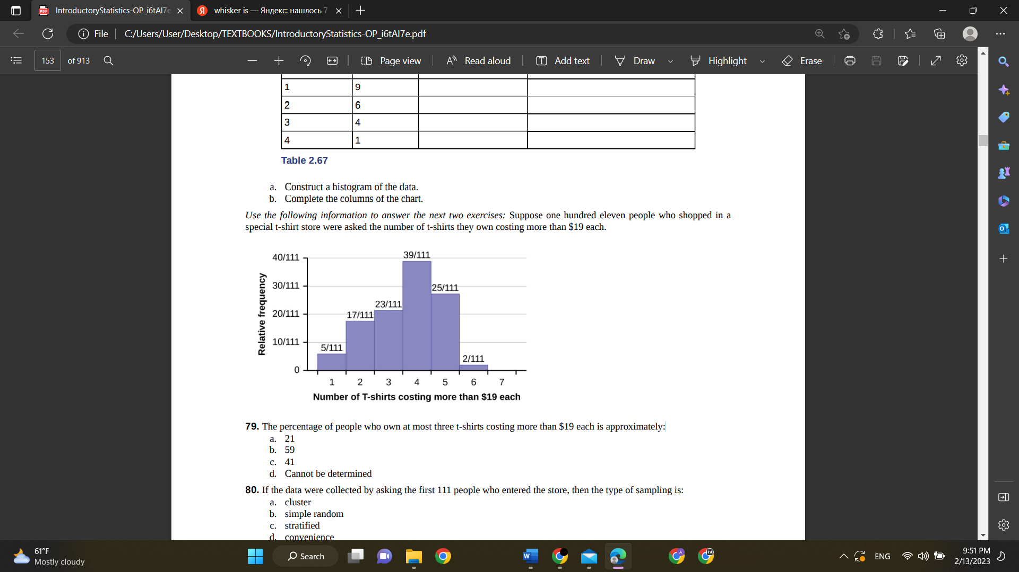  
79. The percentage of people who own at most three t-shirts costing more than $19 each is approximately:

~~a. 21~~

~~b. 59~~

c. 41

~~d. Cannot be determined~~

Answer: c) 41%

23+17+5 = 45 people who own at most 3 t-shirts

Percentage = 45/111 * 100% = 40.54 % 41%

## Section 85:

85. The following box plot shows the U.S. population for 1990, the latest available year.

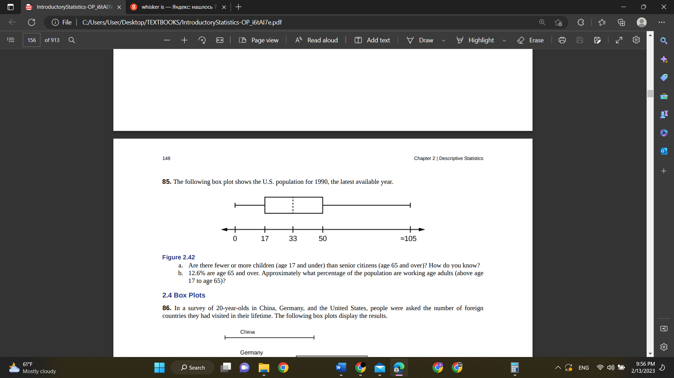

Figure 2.42

a. Are there fewer or more children (age 17 and under) than senior citizens (age 65 and over)? How do you know?

b. 12.6% are age 65 and over. Approximately what percentage of the population are working age adults (above age 17 to age 65)?

Answer:

1. More children; the left whisker shows that 25% of the population are children 17 and younger. The right whisker shows that 25% of the population are adults 50 and older, so adults 65 and over represent less than 25%.
2. 62.4%

## Section 91:

91. The most obese countries in the world have obesity rates that range from 11.4% to 74.6%. This data is summarized in the following table.

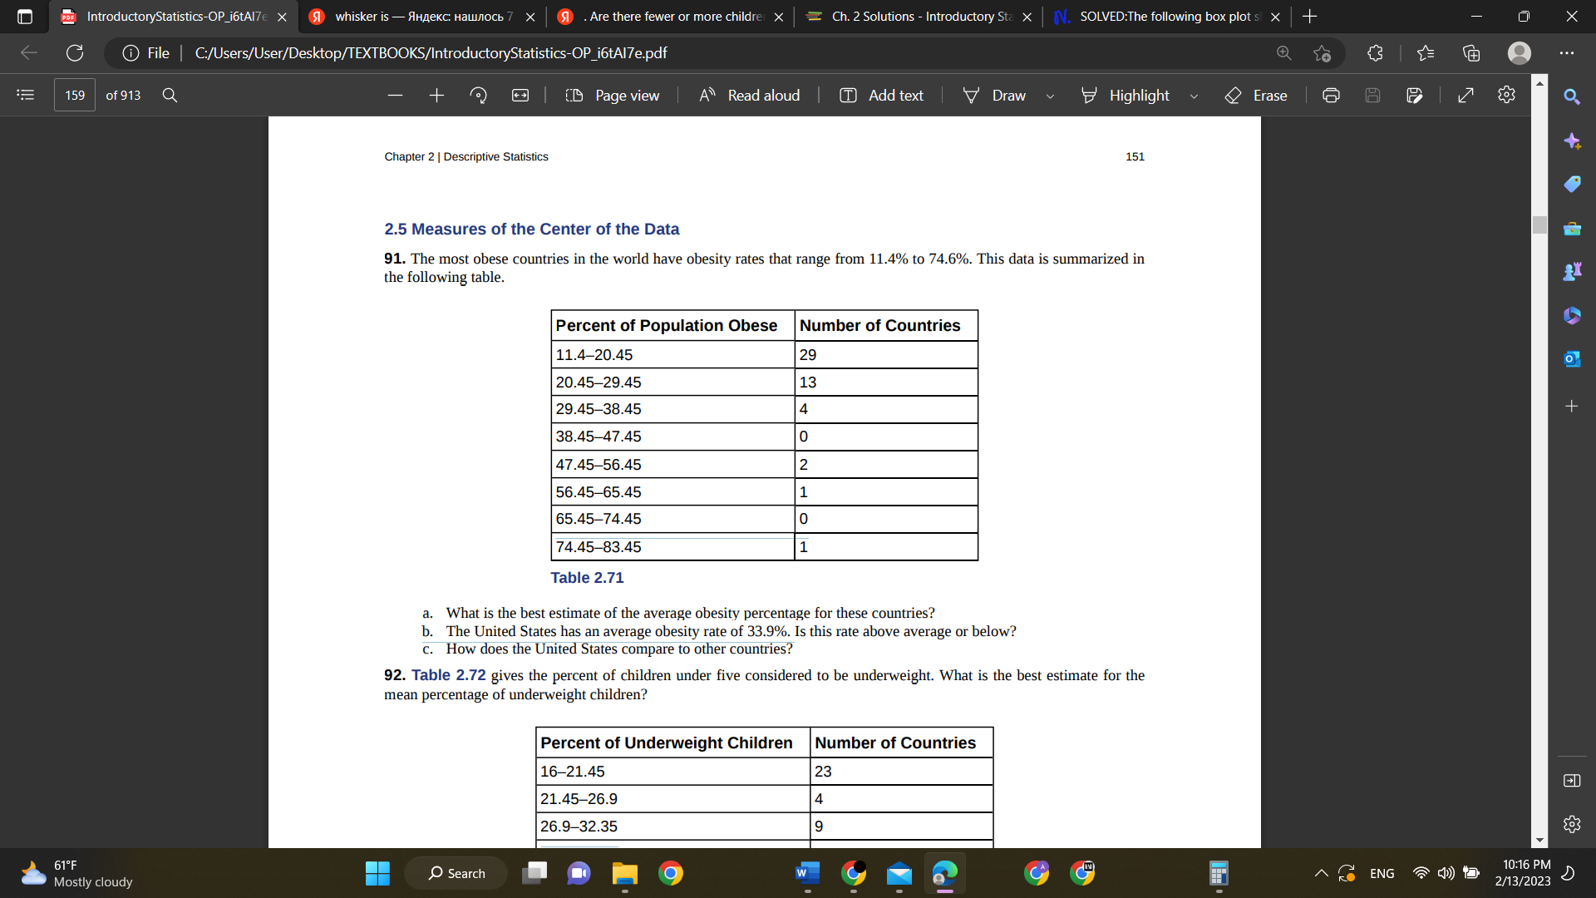

a. What is the best estimate of the average obesity percentage for these countries?

b. The United States has an average obesity rate of 33.9%. Is this rate above average or below?

c. How does the United States compare to other countries?

Answer:

|  |  |
| --- | --- |
| Interval | Midpoint |
| 11.45-20.45 | 15.95 |
| 20.45-29.45 | 24.95 |
| 29.45-38.45 | 33.95 |
| 38.45-47.45 | 42.95 |
| 47.45-56.45 | 51.95 |
| 56.45-65.45 | 60.95 |
| 65.45-74.45 | 69.95 |
| 74.45-83.45 | 78.95 |

1. µ = = = 23.33%
2. USA’s average obesity rate is higher that the average of those countries. 33.9% > 23.33%.
3. USA has higher obesity rate than average of the given countries. USA is one of 4 countries whose obesity rate is between 29.45 and 38.45%.

## Section 93:

93. The median age of the U.S. population in 1980 was 30.0 years. In 1991, the median age was 33.1 years.

a. What does it mean for the median age to rise?

b. Give two reasons why the median age could rise.

c. For the median age to rise, is the actual number of children less in 1991 than it was in 1980? Why or why not?

Answer:

1. Average age is getting higher, because people live longer and/or young children are born rarer.
2. There could be 2 reasons: the population of old people is getting higher. They live longer. And the second reason is: the population of young people is getting down. There are less children born. Or both reasons.
3. We cannot say that for sure. Both 2 reasons affect the result.

## Section 95, 96, 98:

Use the following information to answer the next nine exercises: The population parameters below describe the full-time equivalent number of students (FTES) each year at Lake Tahoe Community College from 1976–1977 through 2004–2005.

• μ = 1000 FTES

• median = 1,014 FTES

• σ = 474 FTES

• first quartile = 528.5 FTES

• third quartile = 1,447.5 FTES

• n = 29 years

95. 75% of all years have an FTES:

a. at or below: _____

b. at or above: _____

96. The population standard deviation = _____

98. What is the IQR? What does the IQR represent?

Answer:

95. 75% of all years have an FTES:

a. at or below: 1447.5

b. at or above: 528.5

96. The population standard deviation = 474 FTES

98. What is the IQR? What does the IQR represent?

1447.5-528.5 = 919

IQR represents the spread of the data. Most occurrence range of the data.

## Section 66,69,71

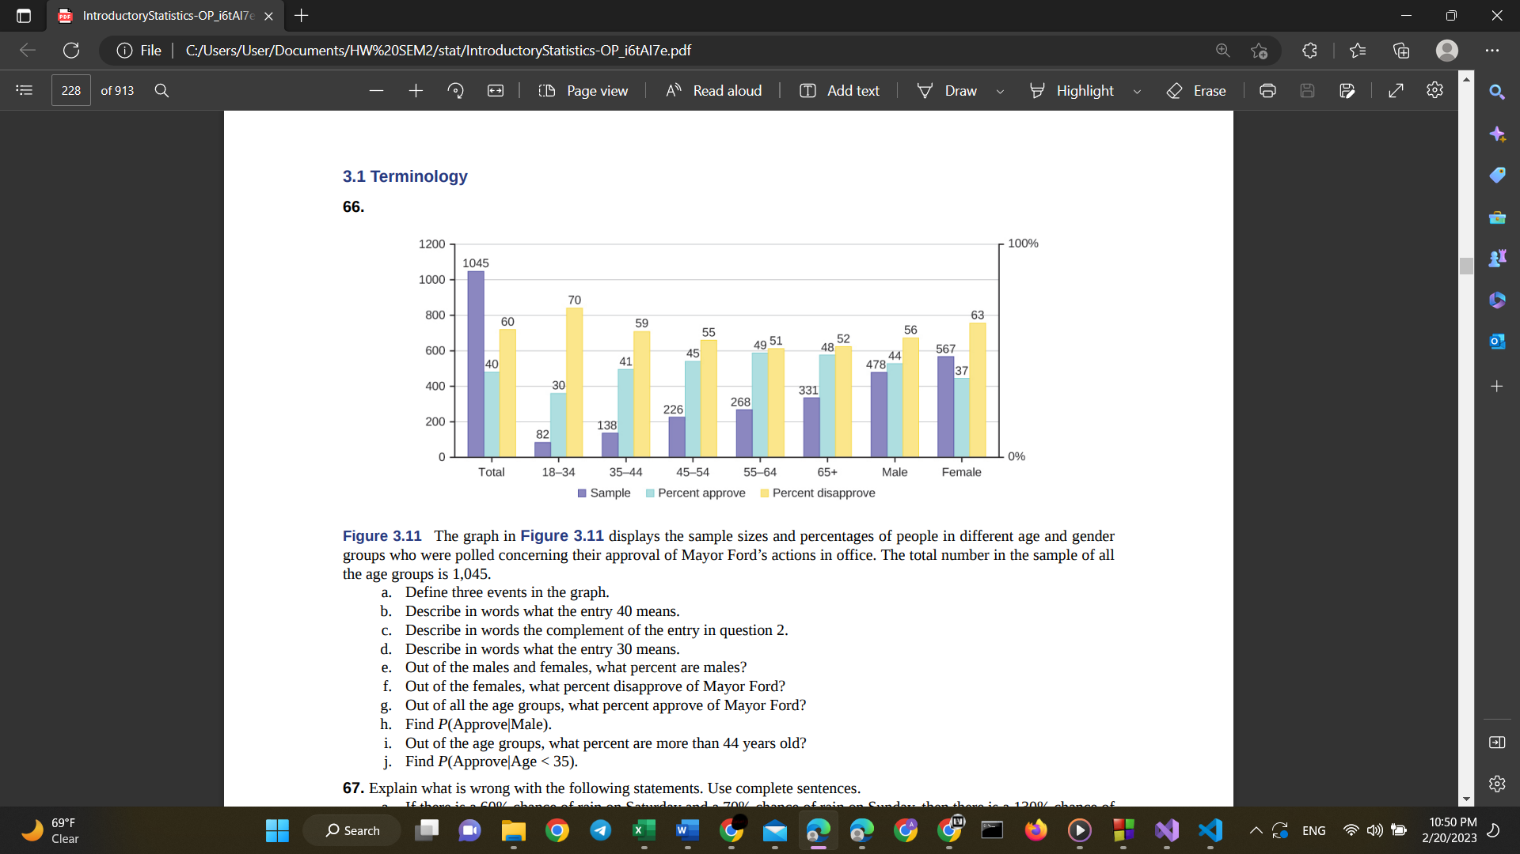

Answer:

a.Individuals who approve M. Ford, males, age:18-34

b.Percent of everyone, who approve Ford

c.Percent of everyone, who disapprove Ford

d.Percent of age group 18-34, who approve Ford

e.478/1045*100=45.7%

f.63%

g.40%

h.0.44

i.(226+268+331)/1045*100%=78.95%

j.all people, age>35 = 138+226+268+331=963

people who approve, age>35 = 138*0.41+226*0.45+268*0.49+331*0.48=448

P(approve|Age>35) = 448/963=0.465

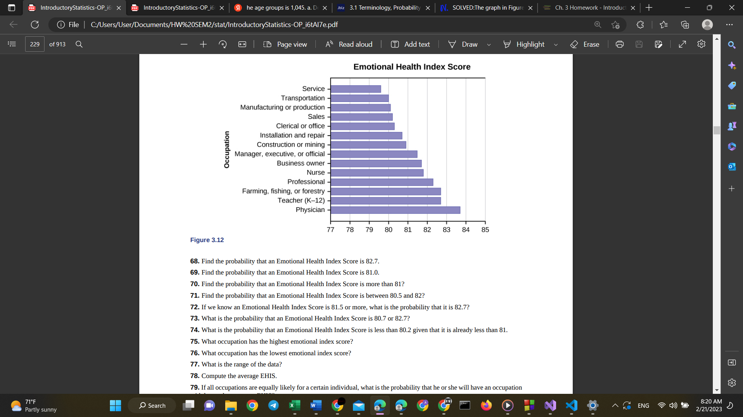

69. Find the probability that an Emotional Health Index Score is 81.0.

71. Find the probability that an Emotional Health Index Score is between 80.5 and 82?

69) at 81.0 there is no entry: so answer is 0

71) 79.5 + 80 + 80.1 + 80.2 + 80.7 + 80.8 + 81.5 + 81.6 + 81.9 + 82.3 + 82.6 + 82.6 + 83.7

Answer: 5 entries are between 80.5 and 82. All entries: 14

So, 5/13 = 0.3571

## Sections 61,63,68,69

61) (10-5.3)/2.1=2.238 🡪 C

63)

a.(77-79)/3.89=-0.5141

b.(85-79)/3.89=1.5424

c. z=3.5🡪🡪h=92.615

height is too high, probably, he wouldn’t be believed.

68) normalcdf(2,1e99,5.3,2.1) = 0.9420

69) invNorm(0.9, 5.3, 2.1) = 7.9913